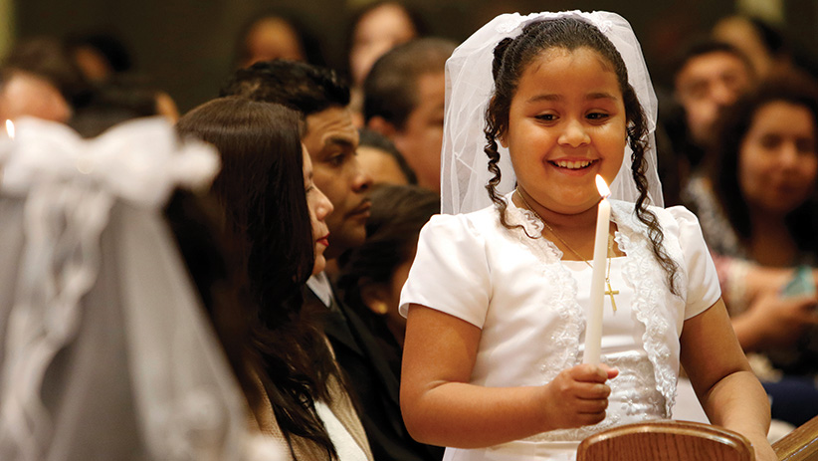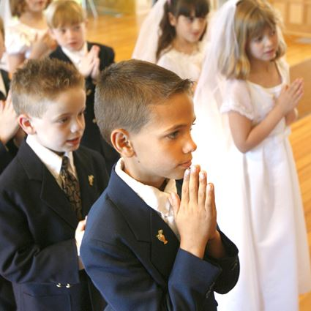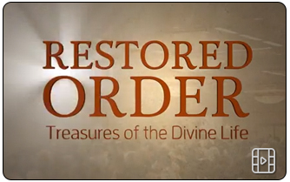

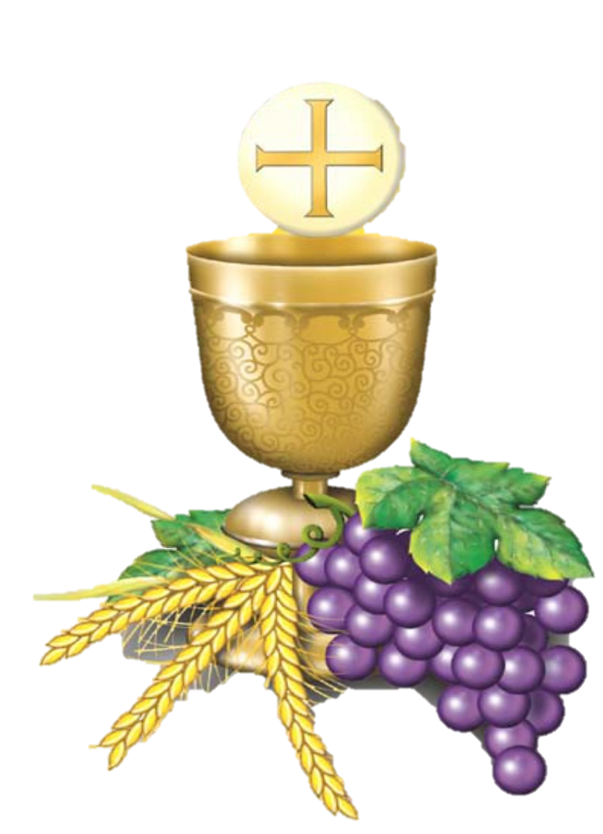

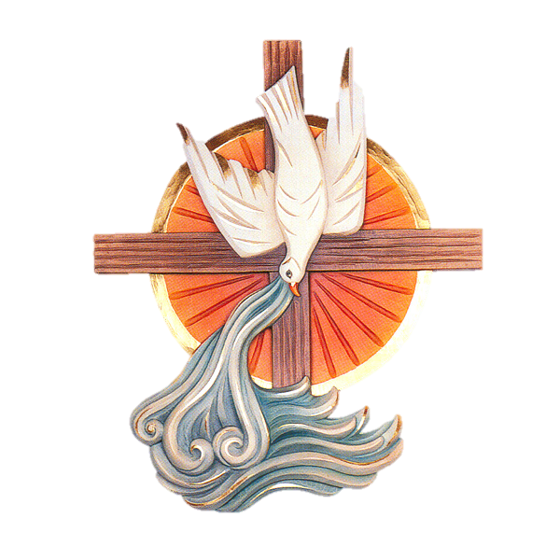

**The Three Sacraments of Initiation are intimately connected.**

In Baptism, the Holy Spirit pours out the gift of Divine Life in our souls.

In Confirmation, our souls are strengthened to allow divine love to pour out into the lives of those around us and carry out Christ’s mission to redeem the world.

In the Holy Eucharist, that life and mission in our souls is nourished with true food, the Bread of Angels, the Real Presence of Jesus Christ.

**A Lifelong Journey!**

* Restoring the theological Order of Christian Initiation: **Baptism, Confirmation, Eucharist**
* Renewing Catholic Culture through the power of the Holy Spirit
* Transforming intimacy with the Heavenly Father and participation in the saving Mission of Jesus Christ

**What *IS* Restored Order?**

Baptism, Confirmation, and Eucharist were all celebrated in the same liturgy for adults and infants for the first 500 years of the Church. Confirmation was separated from Baptism when the Church grew in size and the priest became the normal minister of Baptism. The Bishop made only periodic visits to administer Confirmation. *Restored Order* returns the order of Sacramental initiation to its original form. In the Diocese of Manchester, the normal process will be a two-year preparation, culminating with Confirmation and First Holy Eucharist at the end of 3rd Grade.

**Amazing**

**Grace!**

* Spring 2019, grades 3rd-10th will receive the Grace of Confirmation
* Fall 2018, our G.I.F.T. program will begin an intensive year of Confirmation Prep for the whole parish.
* All adults not yet confirmed are invited to attend our adult sessions to begin their preparation

**Are 3rd Graders too young?**

The Sacraments are free gifts from God, available to anyone at any age, independent of intellectual grasp. Preparedness requires openness to the mystery of God and his love for us, acceptance of what God wants to give us, and the understanding that our participation in the life and mission of Jesus Christ is a lifelong journey of commitment.

**Why is this so important?**

The Sacrament of Confirmation is so intimately connected to Baptism and to the Eucharist that it is impossible to understand in isolation. The outpouring of the Holy Spirit in Baptism and Confirmation is a share in the inexhaustible riches of God, and this Divine Life we receive is continually fed and nourished by the Holy Eucharist.



**FREQUENTLY ASKED QUESTIONS**

**Why is the Diocese of Manchester changing the age of Confirmation to 3rd Grade?** Receiving the gift of Confirmation at this age follows the natural sequence of the Sacraments of Christian initiation. In addition, reception of Confirmation prior to the reception of First Eucharist makes it easier to understand the Eucharist as the summit of the Christian life.

**How will the celebration of Confirmation change in the Diocese of Manchester?** The standard age of Confirmation will be 3rd grade, and Confirmation will be celebrated at the same liturgy as First Communion. As a result, the preparation and reception of the Sacraments of Initiation throughout the Diocese will be Baptism in infancy, Confirmation and Eucharist in 3rd grade. Although not a Sacrament of Initiation, the Sacrament of Reconciliation will be received in the 2nd grade.

**What are the benefits of restored order?** First, it will highlight that the Eucharist, not Confirmation, is the culmination of Christian initiation. Secondly, with the reception of grace of the Holy Spirit at a younger age, it will give children greater courage and guidance in facing the increasing difficulties of living a Christian life. Finally, it will allow for more opportunities for parents to take their rightful place as the primary educators of faith formation. It places sacrament preparation at an age when children are naturally more open and receptive to participating with their parents.

**Does the Church require a certain age for Confirmation?** Both the Rite of Confirmation and the Code of Canon Law (Canon #891) set the age of discretion (age 7) as the age for Confirmation. The USCCB designated the age for Confirmation to be between the age of discretion and age 16, and gave local bishops the ability to determine their policies within that range.

**How will children be able to make an adult commitment to the Church if they are confirmed prior to First Eucharist?** This question reflects a common misconception that the Sacrament of Confirmation signifies maturity and adult commitment to the Church. The maturity that is required for receiving any of the sacraments of Christian initiation is only what is age-appropriate. The Church expects interior dispositions of readiness, such as understanding and freedom that are realistic for a given age, nothing more. Reception of Confirmation only requires the same age-appropriate maturity required to receive the Eucharist. An authentic, mature commitment to Christ and the Church is expressed in lifelong participation in the Eucharist and apostolic life of the Church.

**How can a young child know everything about the faith?** It is impossible to know everything about the faith. Faith Formation is a lifelong process. All youth, kindergarten through high school, are expected to be engaged in faith formation. Adults, too, need to continually learn about the faith, read the scriptures, receive the sacraments, and serve the church and the world thought acts of mercy.

**If children are confirmed earlier, won’t they drop out of faith formation?** They might. It depends on their parents. Confirmation has been misunderstood and often viewed as graduation from faith formation. Growth in the understanding and living out of our faith is the result of a lifelong effort. Parents have the first responsibility of being an example of Jesus Christ to each other and living the Gospel each day. Children will stay in faith formation if they see their parents striving to grow in holiness through family prayer, scripture reading, Sunday Mass, regular Confession, and living a life of service and charity.

**How will restored order affect youth ministry?** Restored order provides great opportunities to revitalize youth ministry. Instead of drawing teens by our own creative efforts and quality ministry, we easily fall into requiring them to be present. This can lead teens to feel like captives being forced to attend. Also, because the sacrament tends to be the focus and goal, few teens stay involved once Confirmation is received. The sacrament is an *initiation* into Christian discipleship. By confirming at the time of First Communion, we make it very clear that Confirmation is not the end but the beginning, not graduation but true initiation into a life of continued growth and intimacy with God. The purpose of parish-based Youth Ministry is the mission of the Church: to evangelize, to build up young disciples through formation, and to send them out as missionaries of Jesus Christ.

**When will this transition happen?** In the Fall of 2018, St. Joseph Parish will begin prepping *all grades (3rd-10th)*, culminating in a series of Confirmation celebrations in the Spring of 2019. The next year, and all subsequent years, the normal process of Christian Initiation will culminate in Confirmation and Holy Eucharist at the end of the 3rd grade year.

**How will this transition happen?** During this year of restoration, our *G.I.F.T.* Family Faith Formation will be Confirmation Prep for Grades 3-8, as well as for all adults who have not yet been confirmed. *Children, Kindergarten – 2nd Grade, will also take part in the *G.I.F.T.* monthly sessions, using the year as an overview of the Sacraments, and 2nd graders will receive additional preparation for the Sacrament of Reconciliation.